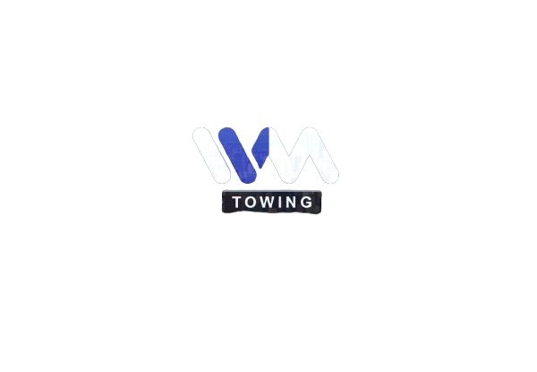

Ivm Towing
If you are looking for professional and ultimate towing services in Melrose Park, then we are here for you as we are set to assist you in your hard times. We offer the utmost assistance to enjoy seamless business and supply chains; if your business involves road freight or logistics, you must be looking for towing near me as you need to be well-prepared with the best tools and associates.
Business Name | IVM Towing
Adress | 2721 Landen Dr, Melrose Park
State | Illinois
City | Chicago
zip code | 60164
phone | (773) 691-0504
website | https://g.page/ivmtowinggrua?share

